3MATrend-PullbackV3

3MAs – typically 30, 50, 100 (or 8, 13, 100)

Blue & Orange arrows are fast crossing medium line
Large Red & Green arrows are medium crossing slow line

Prints 1 ring per timeframe to show strength of trend & opportunities for (re-)entry into trend

Ring Colour | Meaning | Text Colour | Meaning
Green | all 3 MAs in correct order, Long Trend | Neutral | Trend for less than 20 bars
 |  | White | Trend established for > 20 bars
 |  | Yellow | Pullback in trend, monitor
 |  | Green | Possible continuation after pullback
Yellow | Weak long trend indicated  (i.e. medium MA above slow MA)
Amber | Weak short trend indicated  (i.e. medium MA below slow MA)
Red | all 3 MAs in correct order, Short Trend | Neutral | Trend for less than 20 bars
 |  | White | Trend established for > 20 bars
 |  | Amber | Pullback in trend, monitor
 |  | Red | Possible continuation after pullback

Example
Monthly trend long for > 20 bars
Weekly trend long for > 20 bars, pullback, continuation – possible entry
Daily trend short for < 20 bars
H4 weak trend short
H1 trend long for > 20 bars, pullback, continuation – possible entry
M15 weak trend short

Settings
MA1=30 | fast=30MA
MA1Type=0 | simple moving average
MA1Price=0 | closing price
MA2=50 | med=50MA
MA2Type=0 | simple moving average
MA2Price=0 | closing price
MA3=100 | slow=30MA
MA3Type=0 | simple moving average
MA3Price=0 | closing price
TF="yyyyyy" | TF: Monthly, Weekly, Daily, 4hr, hr, M15  set any y to n to switch off the corresponding timeframe  e.g. nnyynn would display daily & 4hr only
TrendThreshold=20 | MAs in correct order for 20 bars = trend
AlertMAX=false | alert on MA cross
EmailMAX=false | send mail on MA cross
AlertPullback=true | alert on pullback - continuation
EmailMAX=false | send mail on MA cross

MAType
MODE_SMA | 0 | Simple moving average,
MODE_EMA | 1 | Exponential moving average,
MODE_SMMA | 2 | Smoothed moving average,
MODE_LWMA | 3 | Linear weighted moving average.

MAPrice
PRICE_CLOSE | 0 | Close price.
PRICE_OPEN | 1 | Open price.
PRICE_HIGH | 2 | High price.
PRICE_LOW | 3 | Low price.
PRICE_MEDIAN | 4 | Median price, (high+low)/2.
PRICE_TYPICAL | 5 | Typical price, (high+low+close)/3.
PRICE_WEIGHTED | 6 | Weighted close price, (high+low+close+close)/4.

3MATrend-Pullback v3

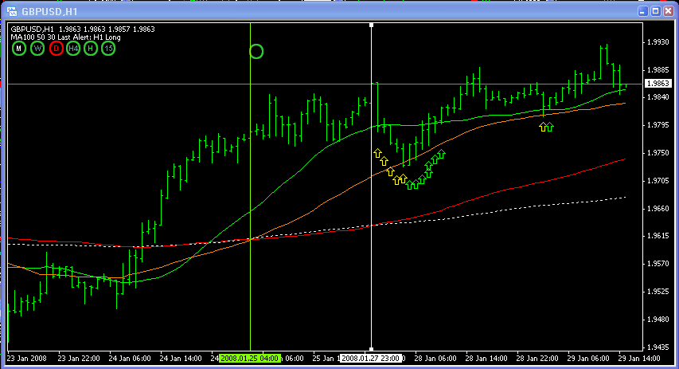

GBPUSD Hourly Chart
Using 100, 50, 30SMA

Green circle appears 25/1 @08.00 (green line)
20 bars by 27/1 @23.00 (white line / white text)

Text turns yellow during pullback (yellow arrows on chart)
Text turns green as price closes higher, then above fast MA (green arrows)
Alerts from 05:00-10:00 – any would have given a good entry

Yellow text again on 29/1 @ 02.00
Green text & alert at 03.00
Again a good entry

